Name:Shreyash Panage

Roll no:58

PRACTICAL NO 09

Aim: To apply the concept of procedure and function

Problem statement:-We have to find the number of years the employee has been in the company

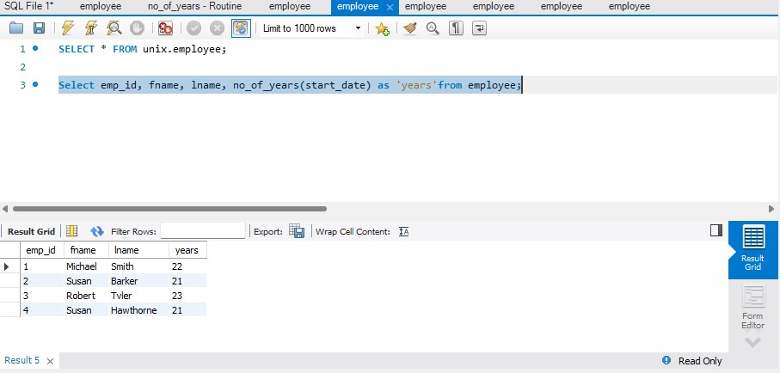\*creating a function

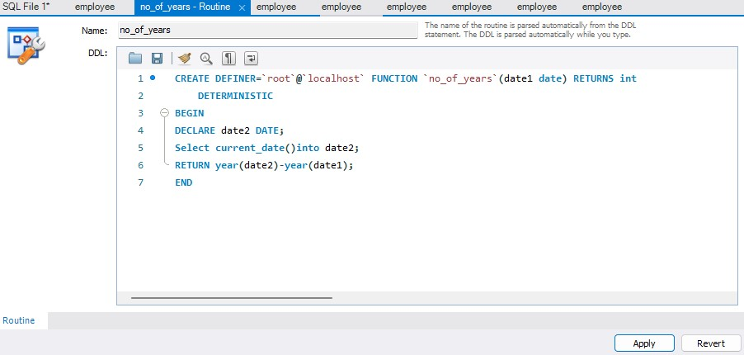

\*function calling

\*output

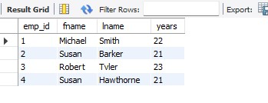

Output:

In this we we perform a functions